Pokhara University

Level: Bachelor | Semester – Spring | Year : 2005
Programme: BE |  | Full Marks : 100
Course: Filter Design |  | Time : 3hrs.

Candidates are required to give their answers in their own words as far as practicable.
The figures in the margin indicate full marks.

Attempt all the questions.

1. | a) Explain the various types of filters in terms of magnitude response? What is the effect of poles and zeros on magnitude response?  b) For the given R-C filter circuit  i) Find the transfer function  ii) Plot pole – zero locations  iii) Plot frequency response  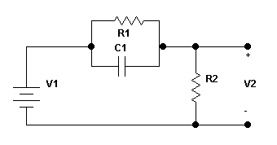 | 8  7
2. | a) Define Positive Real Function. Write down its properties.  b) Realize the two port network of 3rd order Butterworth lowpass filter assuming R1 = R2 = 1 Ω, that is with equal terminations.  OR  Find the Second Foster form of the LC network function F(s) given as  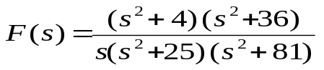 | 3+5  7
3. | a) Determine the orders of the Butterworth and Chebyshev responses to satisfy the following specifications.  b) Explain Frequency Dependent Negative Resistor. | 8  7
4. | a) Define sensitivity function. Perform sensitivity analysis for Tow-Thomas biquad.  b) Discuss Chebyshev Low pass approximation method in filter design? How it is different from Inverse Chebyshev approximation? | 7  8
5. | a) What is the importance of frequency transformation in filter design? Use frequency transformation to find the HP filter network assuming suitable low pass prototype.  b) Design a switched capacitor MOS filter circuit which satisfies the given characteristics:  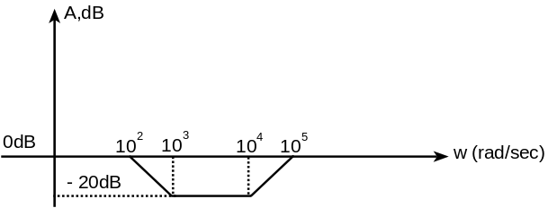 | 7  8
6. | a) Design a LPF such that f_{-3db} = 10 MHz, Passband gain = 5.  b) Design a 3rd order low pass 3 dB filter having Pass band gain 5 and Cut off frequency 5 MHz. Use Sallen Key Unity gain or Sallen Key Equal Component filter. Sketch the circuit diagram of designed circuit.  OR  Why still passive filters are used? Simulate the 5th order low pass Butterworth filter using GIC shown below:  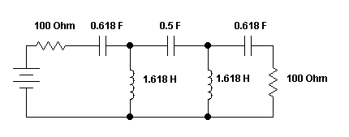 | 5  10
7. | Write short notes on (Any Two):  - Section Sequencing  - Insertion gain and loss  - Transmission and reflection coefficient | 5x2

